 20MCA136 – NETWORKING & SYSTEM ADMINISTRATION LAB Dept. of Computer Applications

**NETWORKING & SYSTEM ADMINISTRATION LAB**

**Name: Sreelakshmi Madhusoodhanan**

**Roll No: 39**

**Batch: B**

**Date: 12/05/2022**

**Experiment No: 16**

**Aim**

Write a shell script program to find the sum of all the digit in a number.

**Program**

#!/bin/bash

echo "Enter a number"

read num

summ=0

while [ $num -gt 0 ]

do

mod=$((num%10))

summ=$((summ+mod))

num=$((num/10))

done

echo $summ

**Output**

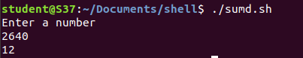

**Experiment No: 17**

**Aim**

**Name: Sreelakshmi Madhusoodhanan**

**Roll No: 39**

**Batch: B**

**Date: 12/05/2022**

Write a shell script program to find the average of number entered in command line.

**Program**

#!/bin/bash

echo "Enter size"

read n

i=1

summ=0

echo "Enter Number"

while [ $i -le $n ]

do read num

summ=$((summ+num))

i=$((i+1))

done

avg=$(echo $summ/$n | bc -l)

echo $avg

**Output**

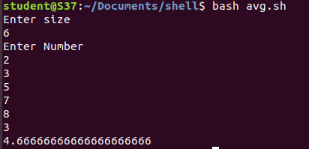

**Experiment No: 18**

**Aim**

Write a shell script to perform additon,subtraction,multiplication and division using switch.

**Name: Sreelakshmi Madhusoodhanan**

**Roll No: 39**

**Batch: B**

**Date: 12/05/2022**

**Program**

#!/bin/bash

echo "Enter two Numbers:"

read a

read b

echo "1. Addition"

echo "2. Subtraction"

echo "3. MUltiplication"

echo "4. Division"

echo "Enter your choice!"

read ch

case $ch in

1)res=`echo $a + $b | bc`

;;

2)res=`echo $a - $b | bc`

;;

3)res=`echo $a \* $b | bc`

;;

4)res=`echo "scale=2; $a / $b" | bc`

;;

esac

echo "Result : $res"

**Output**



